What Data I will need:

1. Property Transaction Data (Essential)

HDB Resale Transactions

Suggested fields:
- Monthly resale price
- Town
(AngMoKio, Bedok, Bishan, Bukit Batok, Bukit Merah, Bukit Panjang, Bukit Timah, Central Area, Choa Chu Kang, Clementi, Geylang, Hougang, Jurong East, Jurong West, Kallang/Whampoa, Marine Parade, Pasir Ris, Punggol, Queenstown, Sembawang, Sengkang, Serangoon, Tampines, Tengah, Toa Payoh, Woodlands, Yishun)

*List of Towns in separate CSV/Excel file*
Alternative:
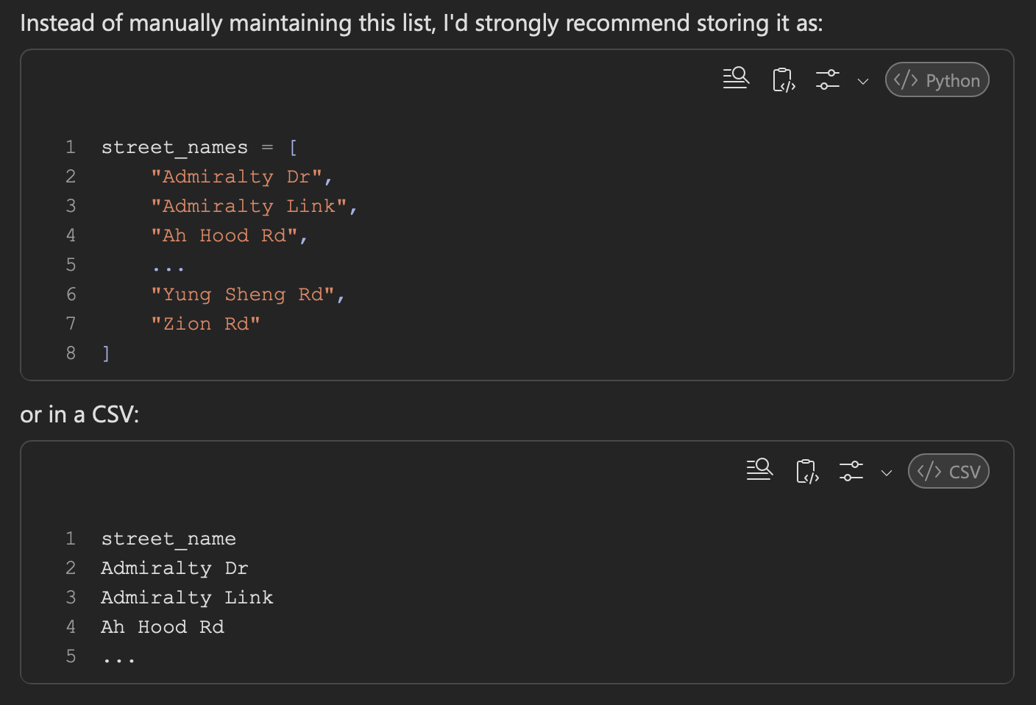

- Block (e.g. 511C, 637B, 12, 10A)
- Street (e.g. St 51, St 72)
- Nearby amenities - Shopping mall, Hospital, MRT (Mass Rapid Transport -> Train Stations in Singapore)
- Flat Type (1Room, 2Room, 3Room, 4Room, 5Room, Executive, Multi-Generation)
- Floor Area (sqm)
- Storey range (e.g 01 TO 03, 16 TO 18, 22 TO 24, 28 TO 30)
*HDB (Singapore’s Housing Development Board) doesn’t reveal exact floor number of the flat due to privacy concerns, therefore the use of ranges*

- Lease commencement date (Year building was finished constructing/commenced)
- Remaining lease (99 years – Year of Commencement)
- Transaction month

Target Variable: -> The thing I want my model to predict

- Resale Price or Transaction Price (Transaction_Price) (SGD)
*Reason: HDB -> Resale Price, Condo -> Transaction Price, Landed -> Transaction Price, Apartment -> Transaction Price*

Model Examples:
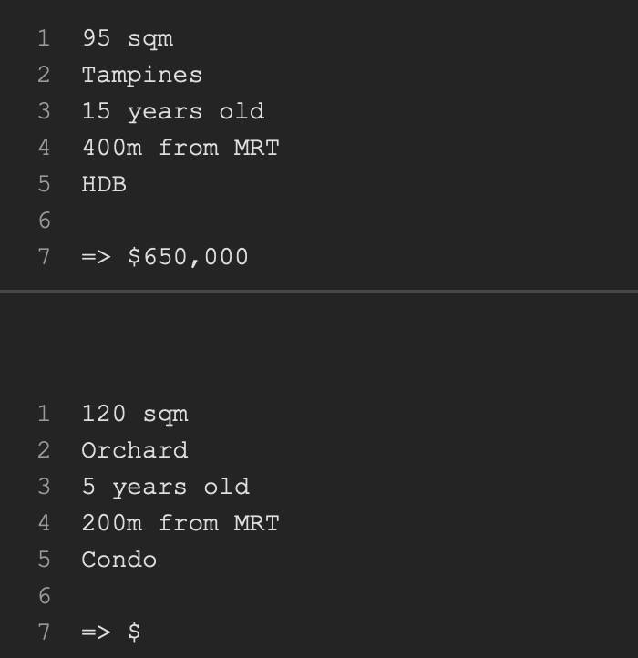

After seeing enough examples, the model learns patterns like:

Bigger area → higher price
Closer to MRT → higher price
Newer property → higher price
Condo → generally higher than HDB
CCR → generally higher than OCR (CCR = Core Central Region, eg. Orchard, River Valley, Tanglin, Newton, Bukit Timah (parts), Marina Bay, Downtown Core) -> Properties here are usually much more expensive
(OCR = Outside Central Region, eg. Tampines, Punggol, Sengkang, Jurong West, Woodlands, Yishun, Choa Chu Kang -> Generally the most affordable private properties)
(RCR = Rest of Central Region, eg. Queenstown, Toa Payoh, Kallang, Geylang, Redhill, Alexandra, Marine Parade) -> near city, but not ultra-prime, prices are between OCR and CCR

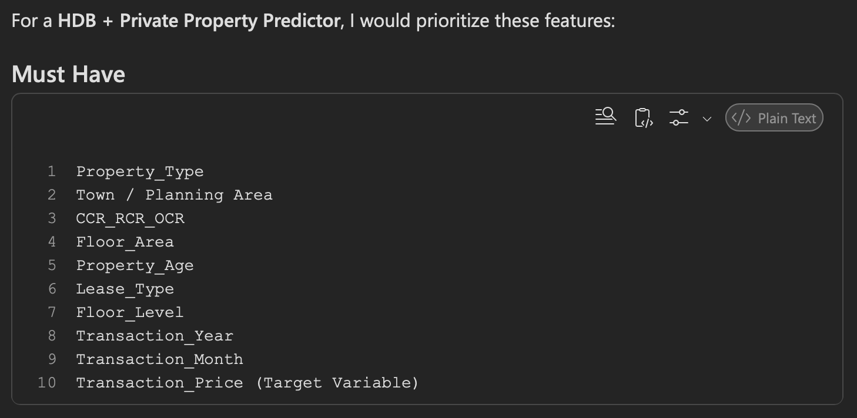

URA Private Property Transaction Data

Suggested fields:
Transaction Price
Property Type
Tenure
Floor area
District
Number of units
Sale date
Building age

Target Variable:
Private Property Price

2. Rental Data (Essential for Rental Yield)

I will need URA Rental Data
Monthly rental value
Property type
District
Rental contract period
Rental yield (%) = (Annual Rental Income / Property Price) * 100

3. OneMap Geospatial Data (Essential)
Useful features:
Distance to amenities
- MRT Station
- Bus interchange
- CBD
- Nearest shopping mall
- Nearest hawker centre
- Nearest polyclinic
- Nearest hospital
- Nearest park
- Nearest Primary/Secondary school
eg. of features generated:
distance_to_MRT
distance_to_mall
distance_to_school
distance_to_hospital

4. Government / Open Data Sources
Population & Demographics - data.gov.sg (property demand is heavily influenced by demographics)
Examples:
Population density
Household Income
Resident Age profile

5. Economic Indicators
(Useful for improving predictions)
Examples:
Mortgage rates
SORA rates
Inflation
GDP Growth
Unemployment Rate
eg. of features:
interest_rate
inflation_rate
gdp_growth

6. Market Trend Data
Report referencing HDB Resale Price Index (RPI)
Include:
HDB RPI
URA Property Price Index
Quarterly Property Price Growth
eg. of features:
market_index
property_cycle_phase

Additional Features: Lease Balance, Location Indicators
- Age of Property:
Property Age = Current Year - Lease Commencement Year
- Remaining Lease = 99 - Property Age (HDB)
- Price per Square Meter = Price / Floor Area
- Floor Category: Low: 1-5 Mid: 6-15 High: 16+

Accessibility Score
Combine: MRT Distance, Bus Distance, Mall distance into one score

School Proximity Score
Distance to: Top Primary schools & Secondary schools

MLM (Machine Learning Models) to use:
Random Forest
Gradient Boosting
Neural Networks
Recommended by Copilot:
Baseline - Linear Regression (Need something to compare against)
Tree Models: Random Forest, XGBoost, LightGBM, CatBoost (These outperform Neural Networks)

OUTPUT I SHOULD SHOW:
1. Data Analysis Dashboard
Visualisations:
HDB Prices over time
Prices by town
Prices by flat type
Rental yields by district
Price distribution

2. Correlation Analysis
Heatmap showing: Feature vs Price
eg. MRT Distance, Lease remaining, Floor area

3. Feature Importance
Show: top 20 factors affecting prices
Factor | Importance
Floor Area | 24%
MRT Distance | 18%
Remaining Lease | 16%

4. Actual vs Predicted Graph
Show: Actual Price vs Predicted Price (Scatter plot?)

5. Rental Yield Analysis
Display: Highest-yield districts, lowest-yield districts, yield prediction results

STRONG FEATURE:
Interactive Map:
MRT locations
Property locations
Predicted prices
Predicted yields
Investment hotspots?
Can be built with: Folium / Plotly / Streamline

Final outcome / deliverable:

User Inputs:
Property Type
Town/District
Floor Area
Floor Level
Lease Remaining
Nearest MRT

System Outputs:
Predicted Property Price
Expected Rental Yield
Confidence Score
Top Influencing Factors

EXAMPLE:

✅ Cleaned integrated Singapore property dataset
✅ Price prediction model
✅ Rental yield prediction model
✅ Model comparison (RMSE, MAE, R²)
✅ SHAP explainability analysis
✅ Interactive Singapore property dashboard/map
✅ Investment recommendation view showing estimated price, yield and drivers of value

Project Brief:
Singapore Residential Property Price Prediction System

Project Objective
Develop a machine learning-based property valuation system capable of predicting the transaction price of residential properties in Singapore.
The system should be able to predict prices for:
- HDB Flats
- Executive Condominiums (EC)
- Private Condominiums
- Apartments
- Landed Properties
The objective is to estimate the expected market value of a property based on historical transaction records and property characteristics.

Data Provided
I will provide the following datasets:

HDB
- HDB Resale Flat Prices (1990 to latest available year)
- HDB Street Names
- Median Resale Prices
- Resale Price Index (RPI) Data

URA
- Private Residential Property Transactions
- Executive Condominium Transactions
- Landed Property Transactions By District

Supporting Materials
- RPI Charts
- Property Transaction Tables
- Random Forest Flowchart

The system should build a master dataset containing as many of the following features as possible:

Property_Type
Town
Street_Name
District
CCR_RCR_OCR

Floor_Area

Storey_Range
Floor_Level

Lease_Type
Property_Age

Transaction_Year
Transaction_Month

RPI

Transaction

Target Variable:
Machine Learning Model should predict: Transaction_Price in SGD Singapore Dollars

Clean Datasets
- Remove duplicates
- Handle missing values
- Standardize column names
- Convert dates correctly
Create additional features like Property_Age = Transaction_Year – Completion_Year
MLM required: Linear Regression, Random Forest Regressor, XGBoost Regressor ??
Display R² Score , RMSE and MAE for each model, compare results and identify the best performing model
User Interface Requirements: the System should allow user inputs like: Property Type, Town/District, Floor Area, Property Age, Lease Type, Storey etc. and receive Predicted Property Price

I require Source Code eg. Python Files, preferably Pandas, Scikit-learn, XGBoost, as well as brief (lengthier if possible for future explanation) documentation on data cleaning process, feature engineering, model selection and the accuracy results.

This project is intended to be a generic Singapore residential property price predictor.

The goal is not to achieve perfect valuation accuracy but to build a practical machine learning system that can estimate property prices using historical HDB and URA transaction data. No need to spend excessive effort collecting additional external datasets. Prioritize building a complete working predictor using the datasets already provided. Additional features such as MRT distance, CCR/RCR/OCR classification and building age may be added if they can be implemented efficiently.

